Employee Management System

# Requirements

1. Rank the usability factors based on their importance and relevance to the system. Write usability requirements for the system.

# Usability Factors:

* 1. **Task Efficiency** - since the application is based on work hours management, payroll and the project milestones, it is important for the application to be efficient.
  2. **Ease of Learning** - as the system must be used by all the staff including cafeteria staff and guards as well that have very little IT experience, Ease of Learning is an important usability factor.

# Usability Requirements:

* **80% of the test users shall find the application easy to use and learn.** (since this application is used daily and every staff uses it, at least 4/5 users should feel that the application is easy to learn and use. 80% of satisfaction is a good feedback)
* **70% of users shall record their work hours in under 3 minutes.** (Since there are staff with very little IT experience, 7/10 users should be able to record their hours in under 3 minutes because 3 minutes is longer than usual for this small task)

# There must be no more than 2 critical problems in total.

* **Users must not encounter more than 15 medium and minor problems combined in total.**

1. **Data Modelling**

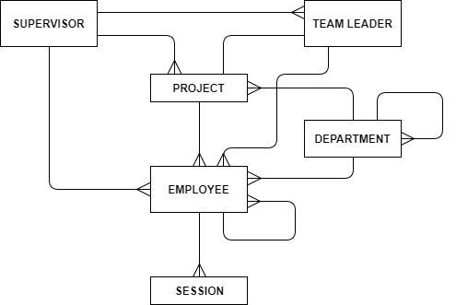

1. **Task Lists:**
   1. **Employee**

T1.1 Manage Hours T1.2 Manage Project

T1.3 Manage Colleague Authorizations

# Supervisor

T2.1 Verify Employee Time T2.2 Check Employee Profile T2.3 Check Project Progress

# Team Leader

T3.1 Manage Project

**Task Descriptions:**

# Employee

|  |  |
| --- | --- |
| **T1.1: Manage Hours**  **Start:** An employee wants to manage his work hours. **End:** The employee successfully manages his work hours. **Frequency:** 2 to 6 times daily.  **Difficult:** Never | |
| **Subtasks** | **Example Solutions** |
| 1. Record In/out time by swiping in through the card reader |  |
| 2. Record in/out time manually |  |
| 3. Add/Delete leave |  |
| 4. Add/Delete unproductive hours |  |
| 5. Check manual work hour count |  |
| 6. Check Flexi- Time |  |

|  |  |
| --- | --- |
| **T1.2: Manage Project**  **Start:** An employee wants to work with his project.  **End:** The employee successfully completes his work with the project.  **Frequency:** 10 to 20 times a day.  **Difficult:** Never | |
| **Subtasks** | **Example Solutions** |
| 1. Check upcoming milestones |  |
| 2. Update current milestone status |  |
| 3. Post milestone updates |  |
| 4. Check achievement status |  |

|  |  |
| --- | --- |
| **T1.3: Manage Colleague Authorizations**  **Start:** An employee wants to manage an authorized task (or) authorize a task to a colleague  **End:** The employee successfully manages the authorized task (or) authorizes the task  **Frequency:** 0.1 times a week.  **Difficult:** Never | |
| **Subtasks** | **Example Solutions** |
| 1. Authorize colleague to update your information |  |
| 2. Update information of a colleague who has authorized you to update |  |

1. **Supervisor**

|  |  |
| --- | --- |
| **T2.1: Verify Employee Hours**  **Start:** A supervisor wants to check the hours of an employee.  **End:** The supervisor successfully checks the hours of the employee.  **Frequency:** Once a week.  **Difficult:** Never | |
| **Subtasks** | **Example Solutions** |
| 1. Check manual entries count of employee |  |
| 2. Report manual entry limit to user |  |
| 3. Reduce RewardPoints of employee whose hours are not authentic |  |

|  |  |
| --- | --- |
| **T2.2: Check Employee Profile**  **Start:** A supervisor wants to check the working track of an employee.  **End:** The supervisor successfully checked the employee’s working track and/or managed  RewardPoints.  **Frequency:** Once in a week for each employee.  **Difficult:** Never | |
| **Subtasks** | **Example Solutions** |
| 1. Check employee milestones |  |
| 2. Review employee achievements |  |
| 3. Increase/Decrease RewardPoints based on employee milestones/achievements |  |

|  |  |
| --- | --- |
| **T2.3: Check Project Progress**  **Start:** A supervisor wants to check the progress of a project.  **End:** The supervisor successfully checks the progress of the project.  **Frequency:** Once in a week.  **Difficult:** Never | |
| **Subtasks** | **Example Solutions** |
| 1. Check project milestones |  |
| 2. Notify on project progress |  |

1. **Team Leader**

|  |  |
| --- | --- |
| **T3.1: Manage Project**  **Start:** A Team Leader wants to manage his project. **End:** The team leader successfully manages his project. **Frequency:** 20 to 30 times a week.  **Difficult:** Never | |
| **Subtasks** | **Example Solutions** |
| 1. Add/Delete milestones |  |
| 2. Update/Modify an existing milestone |  |
| 3. Add/Delete a milestone deadline |  |
| 4. Update/Modify a milestone deadline |  |
| 5. Add/Delete Project meetings |  |